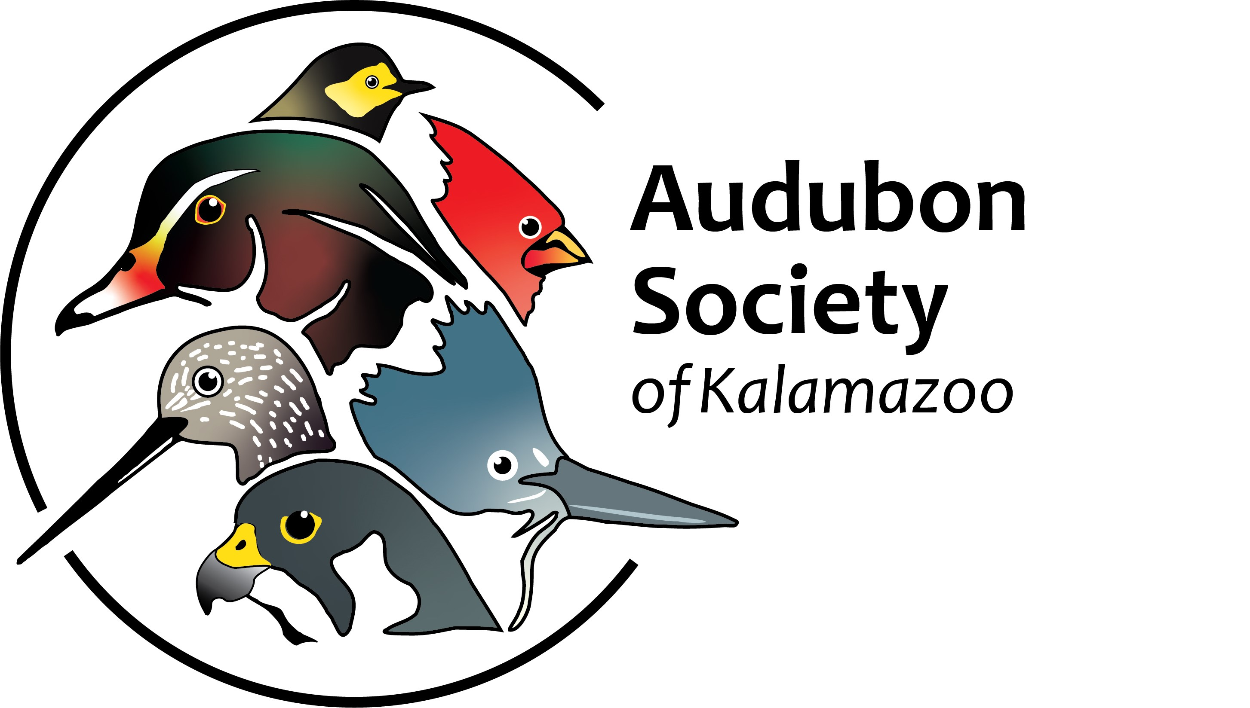

[Audubon](http://www.slfdesign.net/ask/membership-form/) Society of Kalamazoo - Membership/Donation Form

* Adult Membership: $15
* Household Membership: $25
* Student Membership: $5
* Corporate Membership: $100 (or more)

Our membership year starts on July 1st and ends on June 30th of the following year. As a 501(c) (3) organization, contributions to the Audubon Society of Kalamazoo are eligible for charitable deductions on federal income tax returns. You may use the form below to send in your membership and/or donation.

Please make your check payable to the **Audubon Society of Kalamazoo** and send it with your form to:

The Audubon Society of Kalamazoo

PO Box 19333

Kalamazoo, MI 49019-0333

- - - - - - - - - - - - - - - - - - - - - - - - - - - - - - - - - - - - - - - - - - - - - - - - - - - - - - - - - - - - - -- - - - - - - - - - - - - - - - - -

Name(s) _____________________________________________________________________________

Company (if applicable)__________________________________________________________________

Address ______________________________________________________________________________

City _____________________________ State _________________ Zip ____________________________

Phone ________________________________________________________________________________

E-Mail(s) _______________________________________________________________________________

Enclosed is $_______ Circle type of Membership: **Adult Household Student Corporate**

In addition, I am enclosing a donation of $ ___________ to further support the programs of the Audubon Society of Kalamazoo.